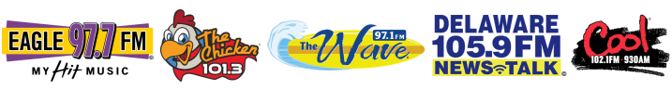

20 March 2020

Dear Chamber Members:

Forever Media Milford/Delaware/Ocean City/Maryland has made available FREE to members, a page on our website at foreverdelmarva.com, where businesses can post their information, absolutely free of charge. The page is up now at:

https://www.foreverdelmarva.com/forever-value-plan/

You will also be able to access it from our home page, foreverdelmarva.com.

There is a form on the site where you can enter your information. We will be promoting the site on ALL of our radio stations; The WAVE, 97.1 FM, EAGLE 97.7 FM, THE CHICKEN 101.3 FM, COOL 102.1 FM, AND Delaware 105.9 FM, which can all be streamed LIVE at foreverdelmarva.com.

Again, for information on businesses in our area that are open and ready to serve our communities, visit foreverdelmarva.com and look for Forever Cares. And if you own a business and want to tell Delmarva about your hours or special offers, post your information free of charge! Visit foreverdelmarva.com

If you would like to have a more formal paid advertisement regarding your business only, contact your Forever Media representative, or you can reach myself, General Sales Manager, John Riebel at (856) 305-2181, or via email by jriebel@forevermediainc.com and we will take care of it immediately. We are taking every precaution by working remotely but have access to all our systems.

Please stay positive and stay safe. We will all get through this!

Thank you.

John Riebel
General Sales Manager
(856) 305-2181
jriebel@forevermediainc.com

