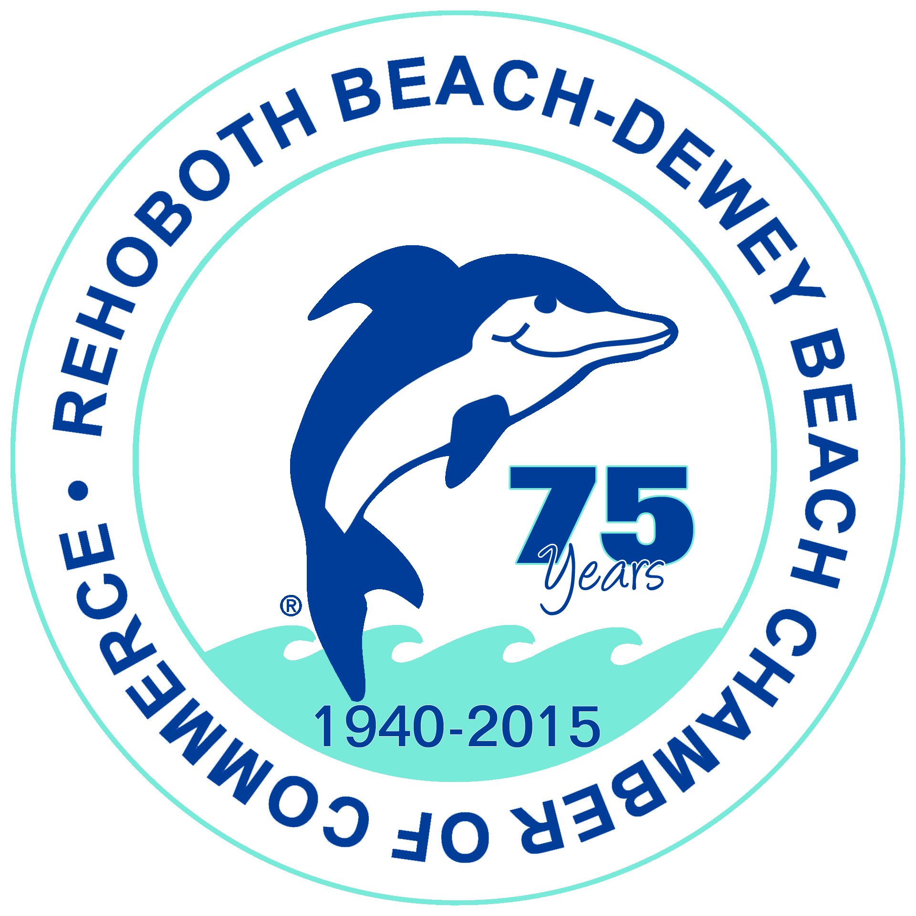
Rehoboth Beach-Dewey Beach Chamber of Commerce & Visitors Center
P. O. Box 216 *501 Rehoboth Avenue, Rehoboth Beach, DE 19971 - 302-227-2233 *800-441-1329
*Hotline 302-227-6446 *Fax 302-227-8351 - rehoboth@beach-fun.com *www.beach-fun.com

TIME SENSITIVE - J-1 SUMMER WORK/TRAVEL PROGRAM IN JEOPARDY
It was recently reported through media, including The Wall Street Journal, that the J-1 Summer Work Travel Program is in jeopardy. The report comes after the President issued a review of immigration rules and practices in the U.S. in order to protect U.S. workers. The Rehoboth Beach-Dewey Beach resort area relies heavily on these student participants to keep our businesses operating at full capacity and providing the level of service that our guests expect. We need to make it clear that these J-1SWT participants are NOT taking American jobs. In seasonal resorts throughout the nation, they supplement the workforce during peak times when we simply do not have access to the number of employees needed.
The Alliance for International Exchange is working aggressively to prevent these programs from being eliminated. Employers are the strongest voices.

Click here to read additional information from the Wall Street Journal article which was provided to us by CIEE (Council on International Educational Exchange).
Please contact our Federal representatives (contact info below) to express your need.

U.S. Senator Thomas Carper – 513 Hart Bldg., Washington, DC 20510 – 202-224-2441; 12 The Circle, Georgetown, DE 19947 – 302-856-7690; E-Mail – Sussex County Regional Director, Karen McGrath, Karen_mcgrath@carper.senate.gov.

U.S. Senator Chris Coons – 127A Russell Senate Office Bldg., Washington, DC 20510 – 202-224-5042; 500 W. Lockerman Street, Suite 450, Dover, DE 19904 – 302-736-5601; E-Mail – Kent/Sussex County Director, Kate Rohrer, kate_rohrer@coons.senate.gov.

U.S. Representative Lisa Blunt-Rochester – 1123 Longworth House Office Building, Washington, DC 20515 – 202-225-4165; 1105 N. Market St., Suite 400, Wilmington, DE 19801 – 302-510-4405.

